

City University

**Mid Term Exam**

**Department Name:** Computer Science & Engineering

**Course Code:** CSE-325

**Course Name:** System Analysis & Design

**Experiment Name**: 1. Use Case of a Banking Apps

2. Class Diagram of an Online Shopping

**Submitted by:**

Name: Hafijur Rahman

ID: 171442648

Program: CSE (Eve)

Batch: 44th

**Submitted by:**

Supta Richard Philip

Sr.Lecturer, Department

City University

Submit Date: 28-May-2019

**Use case**

A use case diagram is a dynamic or behavior diagram in [UML](https://www.smartdraw.com/uml-diagram/). Use case diagrams model the functionality of a system using actors and use cases. Use cases are a set of actions, services, and functions that the system needs to perform. In this context, a "system" is something being developed or operated, such as a web site. The "actors" are people or entities operating under defined roles within the system

**Use Case Diagram of Banking Application**

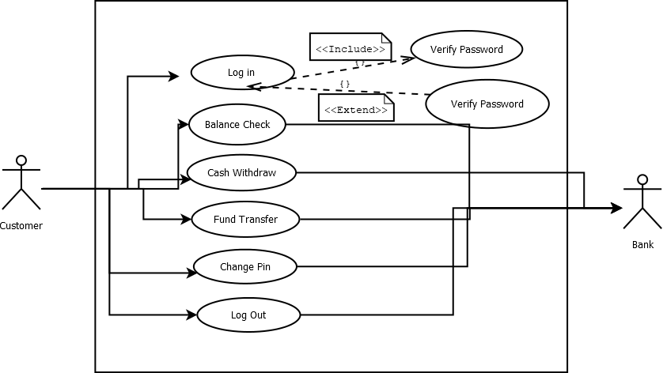

**Abstract**

For solving financial applications of a customer in banking environment in order to nurture the needs of an end banking user by providing various ways to perform banking tasks. This project is developed using PHP, HTML language and MYSQL use for database connection. Creating and managing requirements is a challenge of IT, systems and product development projects or indeed for any activity where you have to manage a contractual relationship. Organization need to effectively define and manage requirements to ensure they are meeting needs of the customer, while proving compliance and staying on the schedule and within budget. The impact of a poorly expressed requirement can bring a business out of compliance or even cause injury or death. Requirements definition and management is an activity that can deliver a high, fast return on investment. The project analyzes the system requirements and then comes up with the requirements specifications. It studies other related systems and then come up with system specifications. The system is then designed in accordance with specifications to satisfy the requirements. The system design is then implemented with MYSQL, PHP and HTML. The system is designed as an interactive and content management system. The content management system deals with data entry, validation confirm and updating whiles the interactive system deals with system interaction with the administration and users. Thus, above features of this project will save transaction time and therefore increase the efficiency of the system.

**Class Diagram:**

Class diagram is a static diagram. It represents the static view of an application. Class diagram is not only used for visualizing, describing, and documenting different aspects of a system but also for constructing executable code of the software application.

Class diagram describes the attributes and operations of a class and also the constraints imposed on the system. The class diagrams are widely used in the modeling of objectoriented systems because they are the only UML diagrams, which can be mapped directly with object-oriented languages.

Class diagram shows a collection of classes, interfaces, associations, collaborations, and constraints. It is also known as a structural diagram.

**Class Diagram of online Shopping**

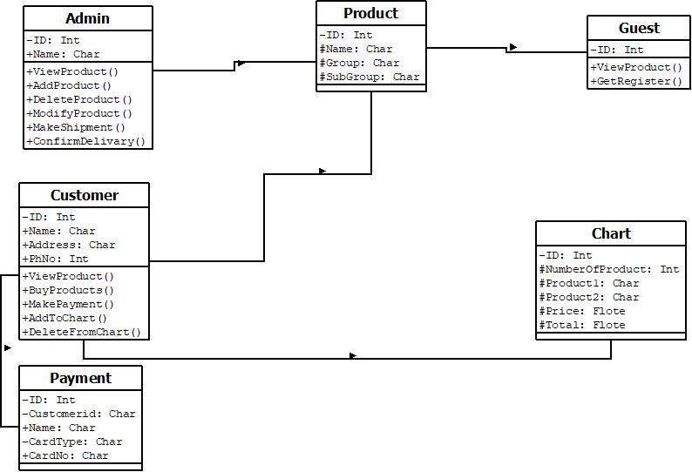

**Class Diagram of online Shopping Discussion**

Conceptual Class Diagram of Online Shopping System. Unified Modeling Language (UML) is the de facto standard for requirements modeling and system design. UML as a visual language can tremendously help customers, project managers, and developers to specify the requirements of a target system. Here we provide an example of UML class diagram which shows a domain model for online shopping. The purpose of the diagram is to introduce some common terms, "dictionary" for online shopping Customer, Web User, Account, Shopping Cart, Product, Order, Payment, etc. and relationships between. It could be used as a common ground between business analysts and software developers. Each customer has unique id and is linked to exactly one account. Account owns shopping cart and orders. Customer could register as a web user to be able to buy items online. Customer is not required to be a web user because purchases could also be made by phone or by ordering from catalogues. Web user has login name which also serves as unique id. Web user could be in several states - new, active, temporary blocked, or banned, and be linked to a shopping cart. Shopping cart belongs to account. Account owns customer orders. Customer may have no orders. Customer orders are sorted and unique. Each order could refer to several payments, possibly none. Every payment has unique id and is related to exactly one account. Each order has current order status. Both order and shopping cart have line items linked to a specific product. Each line item is related to exactly one product. A product could be associated to many line items or no item at all.

Content

|  |  |  |
| --- | --- | --- |
| **Serial** | **Topic** | **Page** |
| 1 | Use case | 3 |
| 2 | Use Case Diagram of Banking Application | 3 |
| 3 | Abstract | 3 |
| 4 | Class Diagram | 4 |
| 5 | Class Diagram of online Shopping | 4 |
| 6 | Class Diagram of online Shopping description | 5 |